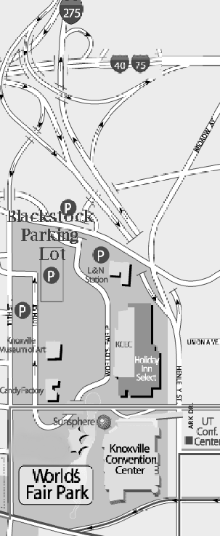
CUMBERLAND AVE
WFEH


Event Name _____ Event Move-Out Date_______
- Once the booth/space is completely packed up, vendors are to go to the Show Office to pick up a load-out pass.
- After receiving a load-out pass, all vehicles must report to Blackstock Lot to receive a dock pass. A dock pass is required to enter the Knoxville Convention Center (KCC) Loading Dock.
- The Marshalling Coordinator will then notify vendor when to report to Knoxville Convention Center Loading Dock.
- Any vehicle not in possession of a dock pass will be asked to return to Blackstock Lot.

Address to Blackstock Parking Lot
640 Blackstock Ave., Knoxville, TN 37916

Address to KCC Loading Dock
813 Cumberland Ave., Knoxville, TN 37902

Thank you in advance for your cooperation!
-KCC Staff-

Security Phone: 865-251-6040
DRIVING DIRECTIONS FROM KCC TO BLACKSTOCK LOT

From the Loading Dock
- Take a left onto Cumberland Ave.
- At red light, turn left onto Henley Street.
- At the fifth red light, turn left onto Oak Avenue.
- At the stop sign turn left onto Blackstock Avenue.
- As you make the left turn you will see the lot on your left.

From Poplar Lot
- Take a right onto Cumberland Ave.
- At the next red light, take a left onto Henley Street.
- At the fifth red light, take a left onto Oak Avenue.
- At the stop sign take a left turn onto Blackstock Avenue.
- As you make the left turn you will see the lot on your left.

DRIVING DIRECTIONS FROM BLACKSTOCK TO THE KCC

From the Blackstock lot
- From lot turn right Oak Avenue
- At red light turn onto Henley Street (441 South).
- At the fifth red light turn right onto Cumberland Ave.
- Next red light turn right onto Poplar Street.
- Entrance to KCC Loading Dock is on the right.

